**Neighborhoods of Baltimore: People, Crime, and Venues**

4/09/2020, CJRR

# 1. Introduction:

1.1: Objective:

Characterize Baltimore’s neighborhoods in terms of their crime rates, age of the residents, population age, median household income, and venues.

## 1.2: Background:

**Client:** The principle client for this is project is Jane New Resident. She is a 38-year-old female professional who is moving to Baltimore. To start her house hunt, she is looking to identify low crime neighborhoods, with grocery stores, shops, restaurants and other professionals.

**Baltimore:** Nicked named “Charm City, Baltimore is the most populous city in Maryland. It is home to the world-renowned Johns Hopkins University and Hospital and numerous tourist destinations including the Pimilico Race Course, the Inner Harbor, and the Maryland Science Center. However, crime in Baltimore is far above the national average and the city has a practically high murder rate. The city is divided into nine geographic regions and over 50 neighborhoods: each neighborhood having its own character. The city’s crime is generally concentrated in the neighborhoods with high rates of poverty. [1]

## 1.3. Analytic Approach:

To help Jane select neighborhoods for her house hunt, this analysis will collect and generate summary data on the crime, number and type of venues, median income, age, and household size, for each neighborhood. It will then cluster the neighbors, summarize each cluster and display the information in an interactive map. This will allow Janes review the character of each cluster and selects a subset of neighborhoods to start searching in.

# 2. Data:

2.1 Data Requirements:

The analysis describes in 1.3 will require the following data:

* List of the neighborhoods in Baltimore
* The geographic boundaries of the neighborhood
* General crime statistics for each neighborhood
* General demographic statistics for each neighborhood
* Venue information for each neighborhood

The client wants to understand the general character of neighborhoods so she can start house hunting. She is worried about the crime rate. The analysis will need to include an overall picture of the crime rate of each neighborhood.

She is looking to live near other like-professionals – a factor that is not easy to characterize. However demographic information may help identify those neighborhoods – specifically by examining the median income, the average household size, and the percentage of people that are in the 25 to 64-year-old age group. Because the crime rate is related to the high poverty areas, the analysis will include that as well.

She is interested to understand the character of neighborhoods in term of the available shopping and restaurants. For each neighborhood a listing the type and number of nearby venues will be used.

There are over 50 neighborhoods in Baltimore. The client wants to consider them in like character clusters so that she does not over constrain her house hunting options.

## 2.2 Data sources:

2.2.1 Crime and Safety:

2015 Crime and Safety data for Baltimore City is available on Data.gov here:

<https://catalog.data.gov/dataset/crime-and-safety-2015>

This data set represent the year 2015’s values for Crime and Safety from Vital Signs published by the Baltimore Neighborhood Indicators Alliance. For more information, please visit http://www.bniajfi.org/vital_signs.

The crime statistics are organized by neighborhood includes the following features:

* Part 1 Crime Rate per 1,000 Residents
* Violent Crime Rate per 1,000 Residents
* Property Crime Rate per 1,000 Residents
* Juvenile Arrest Rate per 1,000 Juveniles
* Juvenile Arrest Rate for Violent Offenses per 1,000 Juveniles
* Juvenile Arrest Rate for Drug Offenses per 1,000 Juveniles
* Rate of 911 Calls for Service for Shootings per 1,000 Residents
* Rate of Gun Homicides per 10,000 Residents
* Rate of 911 Calls for Service for Common Assaults per 1,000 Residents
* Rate of 911 Calls for Service for Narcotics per 1,000 Residents
* Rate of 911 Calls for Service for Auto Accidents per 1,000 Residents
* Adult Arrest Rate per 1,000 Adults

For this analysis, of the above options, the following statistics will be included:

* Part 1 Crime Rate per 1,000 Residents
* Violent Crime Rate per 1,000 Residents
* Property Crime Rate per 1,000 Residents

Example:

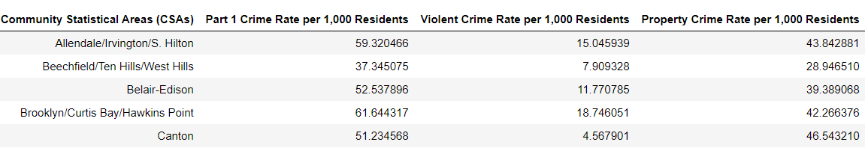

### 2.2.2 Demographics:

2015 Census demographics data for Baltimore City is available on Data.gov here:

<https://catalog.data.gov/dataset/census-demographics-2015>

This data set represent the year 2015’s values for Census Demographics from Vital Signs published by the Baltimore Neighborhood Indicators Alliance. For more information, please visit <http://www.bniajfi.org/vital_signs>.

The demographics statistics are organized by neighborhood and includes the following features:

* Percent of Residents - Black/African-American
* Percent of Residents - White/Caucasian Percent of Residents - Asian
* Percent of Residents - Two or More Races
* Percent of Residents - All Other Races
* Percent of Residents - Hispanic Racial Diversity Index
* Percent of Population Under 5 Years Old
* Percent of Population 5-17 years old
* Percent of Population 18-24 years old
* Percent of Population 25-64 years old
* Percent of Population 65 years and over
* Total Number of Households
* Percent of Female-Headed Households with Children Under 18
* Percent of Households with Children Under 18
* Average Household Size
* Median Household Income
* Percent of Households Earning Less than $25,000
* Percent of Households Earning $25,000 to $40,000
* Percent of Households Earning $40,000 to $60,000
* Percent of Households Earning $60,000 to $75,000
* Percent of Households Earning More than $75,000
* Percent of Family Households Living Below the Poverty Line
* Percent of Children Living Below the Poverty Line

For this analysis, of the above options, the following statistics will be included:

* Percent of Population 25-64 years old
* Average Household Size
* Median Household Income
* Percent of Family Households Living Below the Poverty Line
* Total Number of Households – to calculate population density

Example:

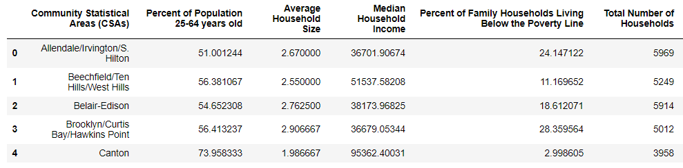

### 2.2.3 Neighborhoods and Boundaries:

Both the demographics and crime data sets include a list of neighborhoods names and geographic boundaries. See below for a map of Baltimore Community Statistical Areas, hereafter referred to as neighborhoods, and the centroid of each neighborhood:

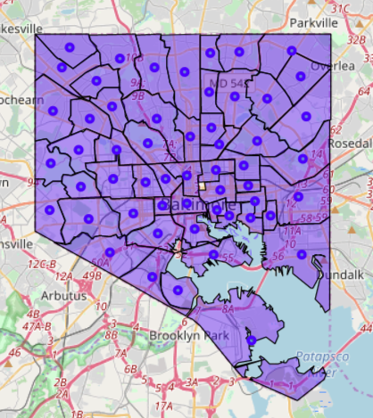

### 2.2.4 Venues types and Counts:

Foursquares will be used to generate a list of venues near each neighborhood’s center.

. 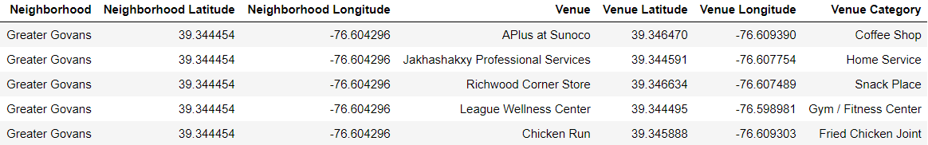

# 3. Methodology:

## 3.1: Data Wrangling:

### 3.1.1 Formatting and reformatting….

The 2015 crime and statistics and census data files posted on data.gov were a mess. The json files were not in a readable format. The CSV files had formatting inconsistencies. All the data was present, to make them workable they had to be manually reformatted. When completed there were three files. A CSV containing the crime and safety data, a CSV containing the census data, and a GEOJSON file containing multipolygon shapes for each neighborhood. The reformatted files are posted here:

GEOJSON:

<https://github.com/AstroCris/CoureraCourses/blob/master/Baltimore44.geojson>

2015 Demographics:

<https://github.com/AstroCris/CoureraCourses/blob/master/Census_Demographics__2015__data_clean.csv>

2015 Crime and Safety:

<https://github.com/AstroCris/CoureraCourses/blob/master/Crime_and_Safety__2015__data_clean.csv>

### 3.1.2 Reading and Slicing:

**GEOJSON:**

Simply reading the GEOJSON file and using Folium to produce a choropleth map produces the desired result. Each region the corresponds to a neighborhood is colored. The color has no value in this example.

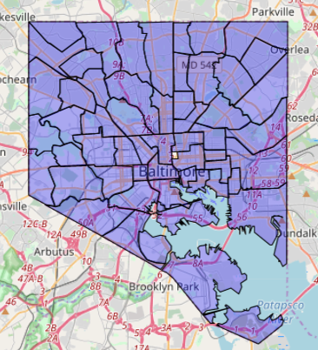

Figure: Neighborhoods

The uncolored region in the center of the city, initially was a concern. However, that region corresponds to the city jail. The data sets do not include any crime or demographics information for this region. Nor is it relevant to our house hunting client.

**2015 Crime and Safety Data:**

Using pandas to reading the crime and safety CSV file produces the following dataframe (as viewed with .head() )

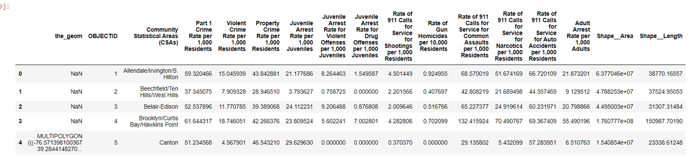

The NaN entries in the_geom column are entries where the multipolygon was corrupted in the csv and were manually removed. Those entries were corrected manually in the GEOJSON file.

Selecting the desired features (as discussed in section 2.2.1) and simplifying the column names produces the following dataframe:

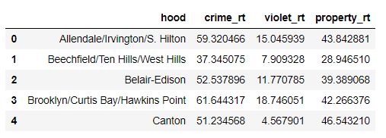

**2015 Demographics:**

Using pandas to reading the 2015 Census CSV file produces the following dataframe (as viewed with .head() )

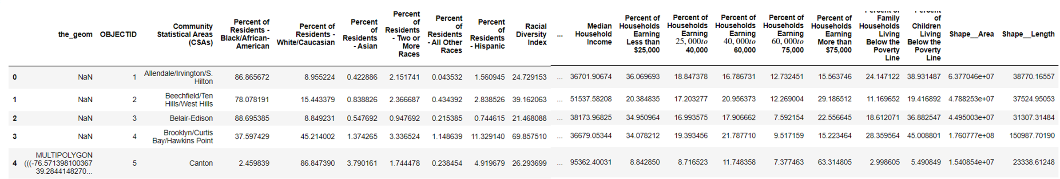

The NaN entries in the_geom column are entries where the multipolygon was corrupted in the csv and were manually removed. Those entries were corrected manually in the GEOJSON file.

Calculate population density per acre by multiplying the total number of households by the average household size and dividing by the area of the neighborhood. Multiplying the result by 43560 converts the result from 1/ft2  to 1/acres.

Selecting the desired features (as discussed in section 2.2.2) and simplifying the column names produces the following dataframe:

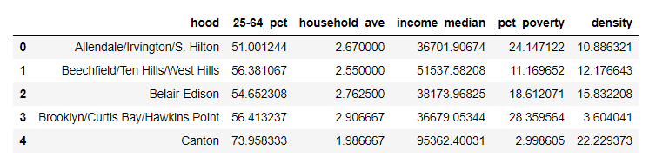

### 3.1.3 Neighborhoods Coordinates

The GEOJSON file contains the multipolygon shape of each neighborhood, expressed as a list of Latitude and longitude coordinates. However, the Foursquares API requires a single coordinate point (expressed as Latitude and Longitude) and a radius (in meters).

The GEOJSON data should be sufficient to calculate a reasonable center coordinates for each neighborhood. As a first attempt the average of the latitudes and longitudes for each neighborhoods’ multipolygon was calculated. However, this produced erroneous results:

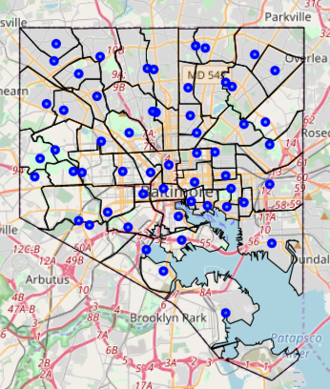

Figure: Neighborhood centers calculated by averaging

This averaging method is biased by the density of points needed to define each edge. More complicated edges require more points to define it. This shifts the calculated average coordinates towards that edge.

A more mathematically valid approach is to calculate the centroid of the polygon shape. See [centroid](https://en.wikipedia.org/wiki/Centroid) for more information. The python library shapely has a function to this. See [shapely](https://shapely.readthedocs.io/en/latest/manual.html#geometric-objects) for more information. Using this function produced superior results:

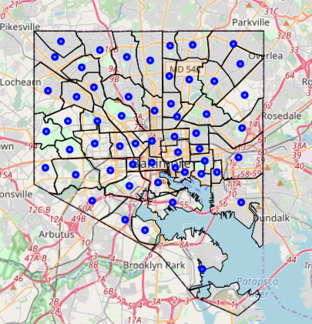

Figure: Neighborhood centroids

Centroid latitude and longitude for each neighborhood was loaded into a dataframe:

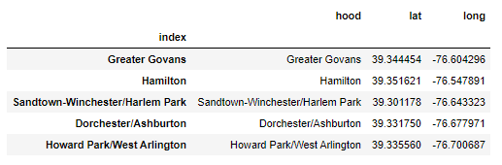

### 3.1.3 Venue Data:

Foursquares was used to collect a list of venues details (name, location, category) for venues within 1000 meters of each neighborhoods’s centroid, up to 100 venues for each neighborhood. A total of 889 venues in 216 unique categories were collected. The result loaded into a dataframe has this form:

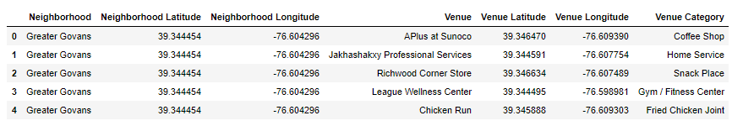

The geographic distribution of the 889 venues:

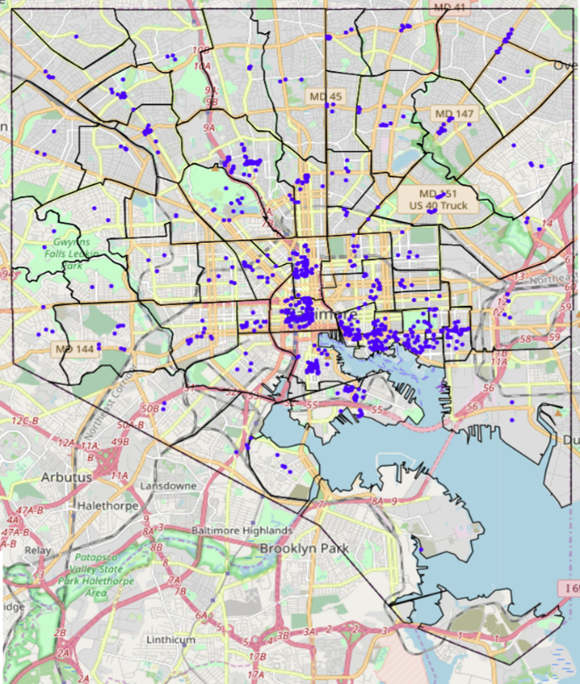

Figure: Foursquare venues with in 1000 m of each neighborhood’s centroid

On inspection some neighborhoods are sparsely populated with Foursquare venues. For example, Foursquares did not return any venues in Mount Washington Village, despite the presence of shops, restaurants, art galleries, a church, and a school in the village. Increasing the query radius did not resolve this problem. This call into question the validity of all the results that follow. See Discussion for more detail.

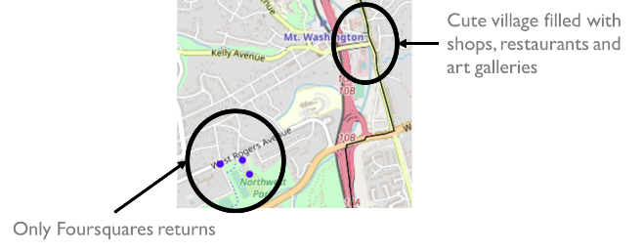

Figure: Where are the Mount Washing Village’s venues?

Since the objective is to characterize each neighborhood, the list of venues need to be translated into a summary for each neighborhood. Firsts using one-hot-encoding the venue categories are converted new columns and a ‘1’ is placed to indicate which category that venue is, and zero is placed otherwise. The result has this form:

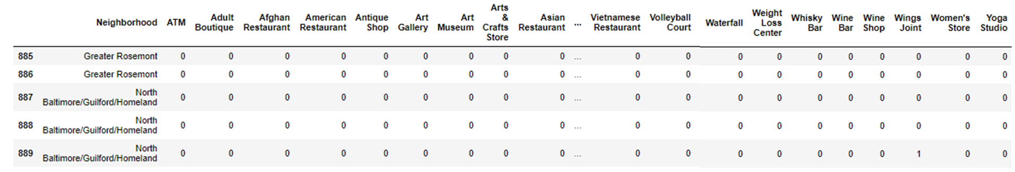

Next the venues are grouped by neighborhood, summing the number of venues for each category:

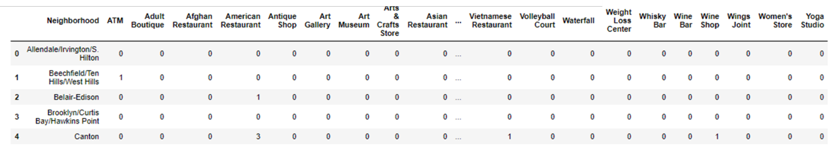

Now the venue data is in a form that is relevant to the analysis objective.

### 3.1.4 Merging DataFrames

Merging the crime, census, and coordinates data frames to make a data frame for summary information:

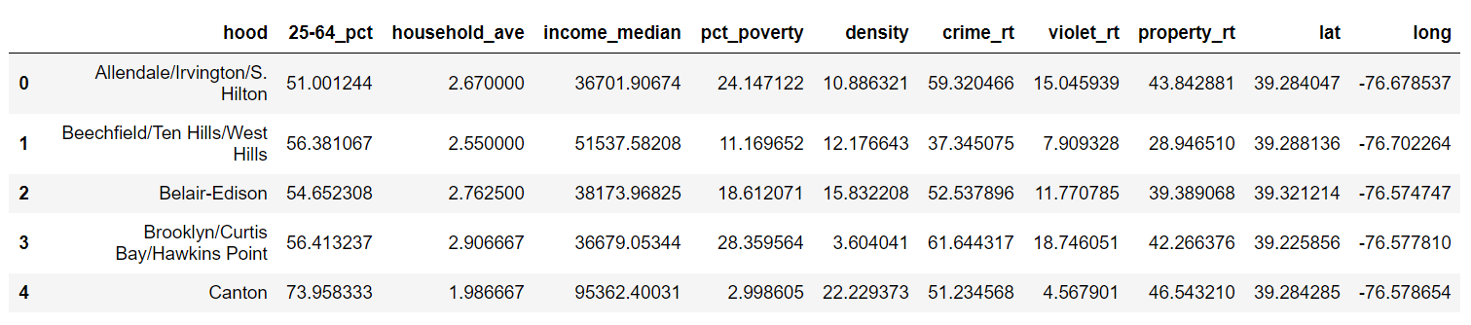

Merging the crime, census and venues counts data frames to make a data frame that contains the relevant data for clustering:

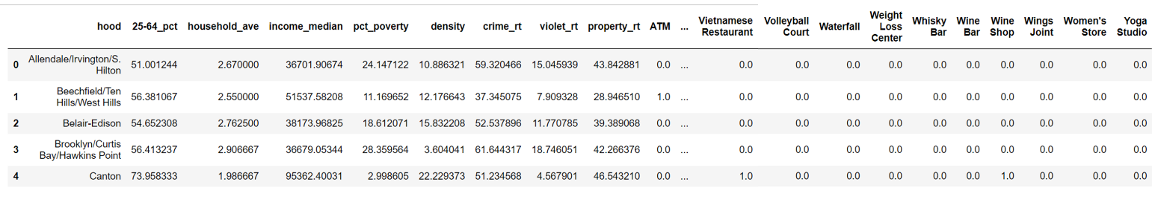

## 3.2: Data Exploration:

### 3.2.1 Crime Rate:

How do the crime rates vary from neighborhood to neighborhood?

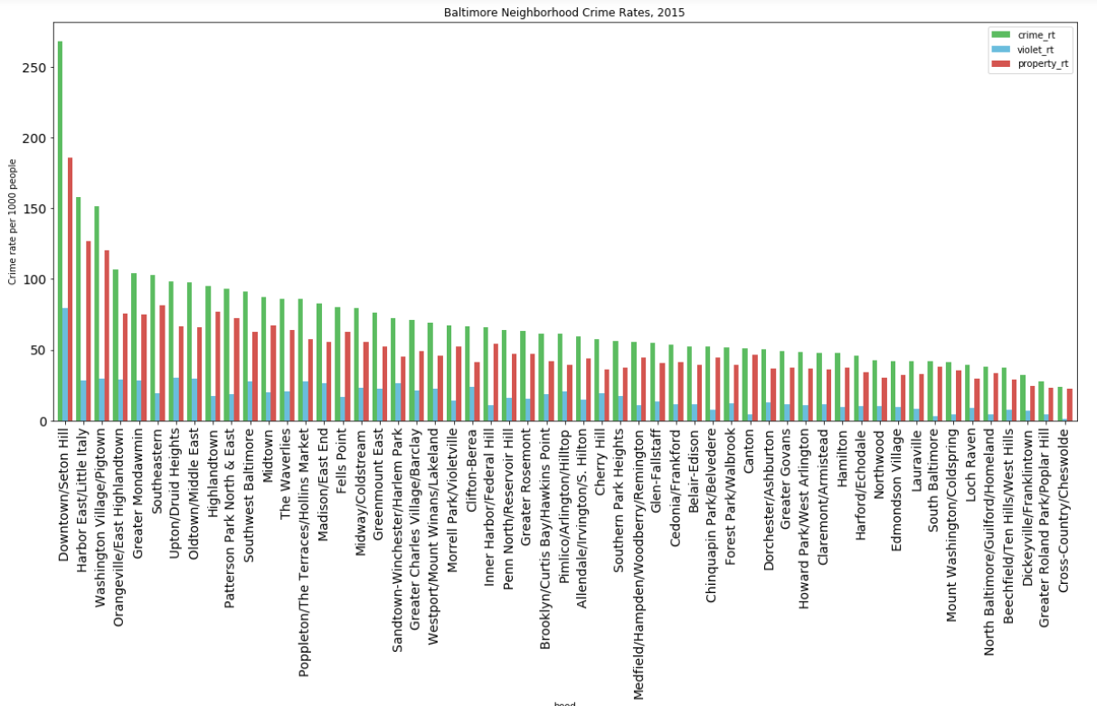

Figure: Total Crime rate (green), violent crime rate (blue), property crime rate (red) in 2015.

Geographically how do the crime rates vary?

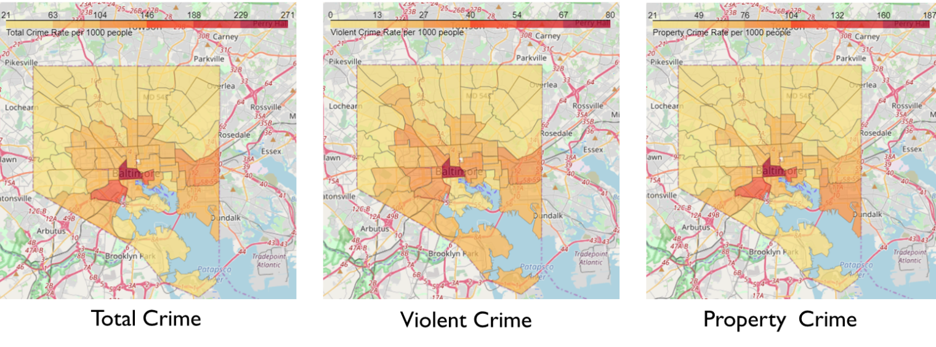

Figure: Geographic distribution of crime rates, per 1000 people, in 2015.

### 3.2.2 Median Household Income:

How does median household Income vary neighborhood to neighborhood?

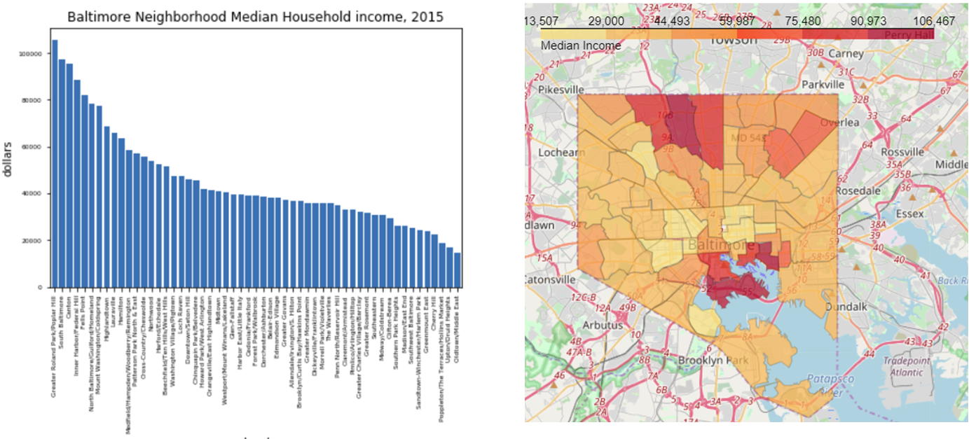

Figure: Median Household Income, 2015

### 3.2.3 Poverty:

How does the percentage of household in poverty vary neighborhood to neighborhood?

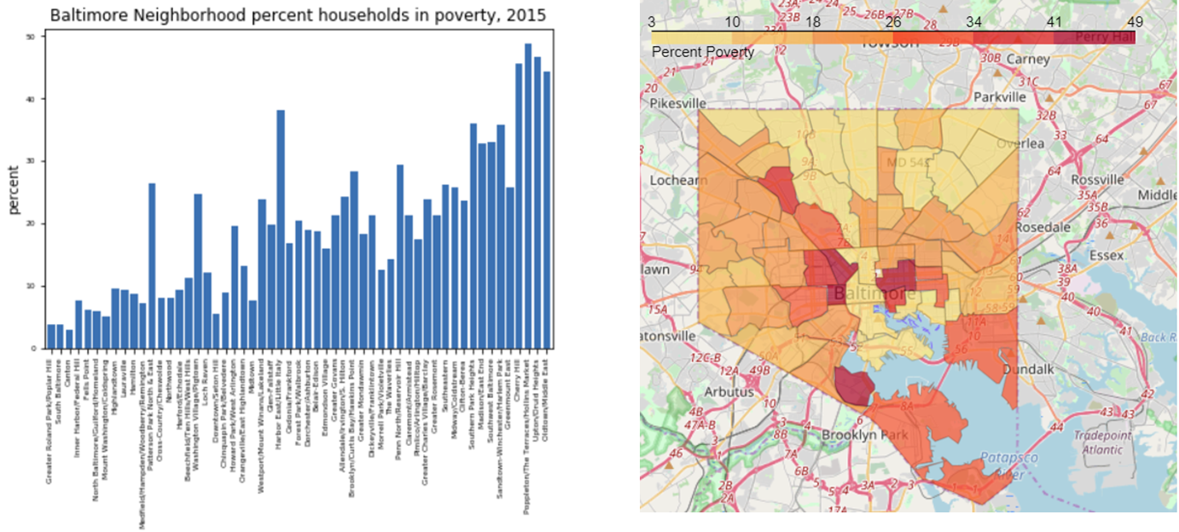

Figure: Percent of household in poverty, 2015

### 3.2.4 Working age population:

How does the percent of the population that are 25 -64 years old vary neighborhood to neighborhood?

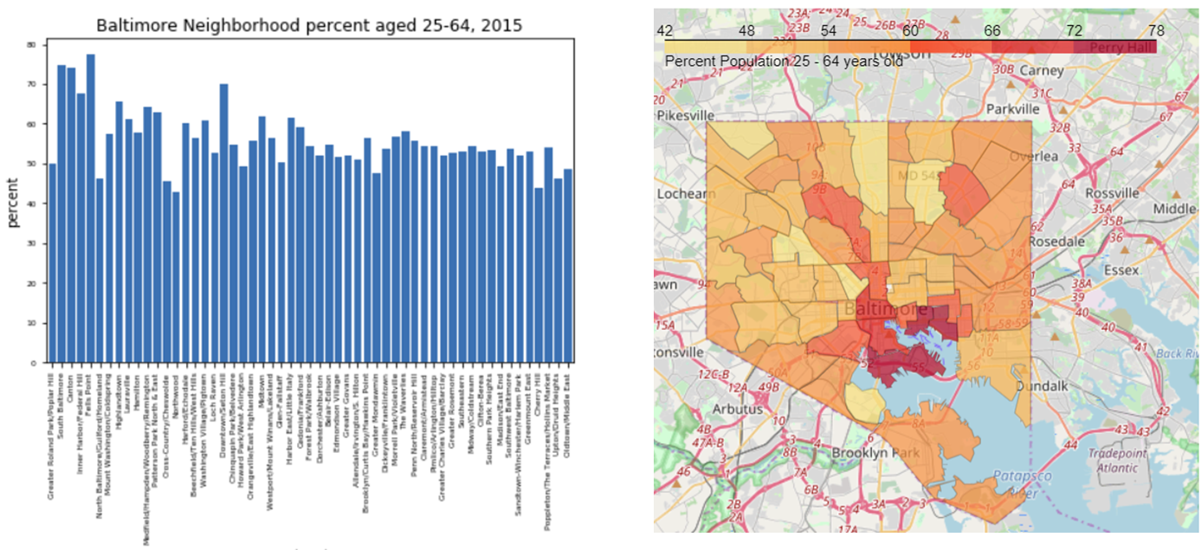

Figure: Percent of the population that is 25 -64 years old, 2015

### 3.2.5 Household size:

How does the average household size vary neighborhood to neighborhood?

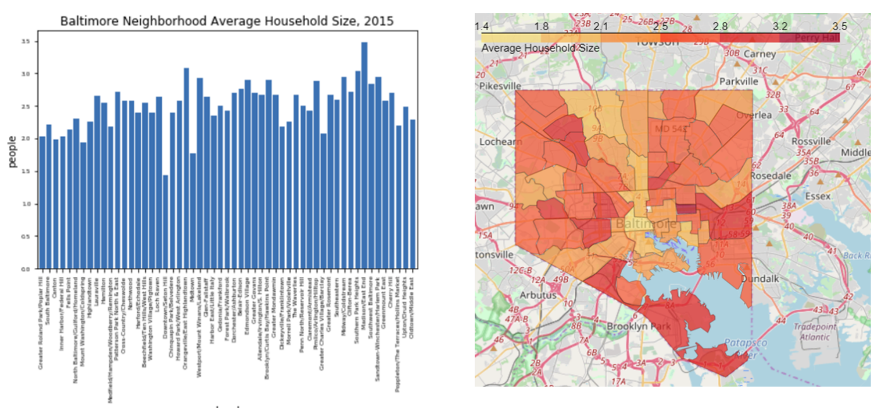

Figure: Average household size, 2015

### 3.2.6 Population Density:

How does the population density vary neighborhood to neighborhood?

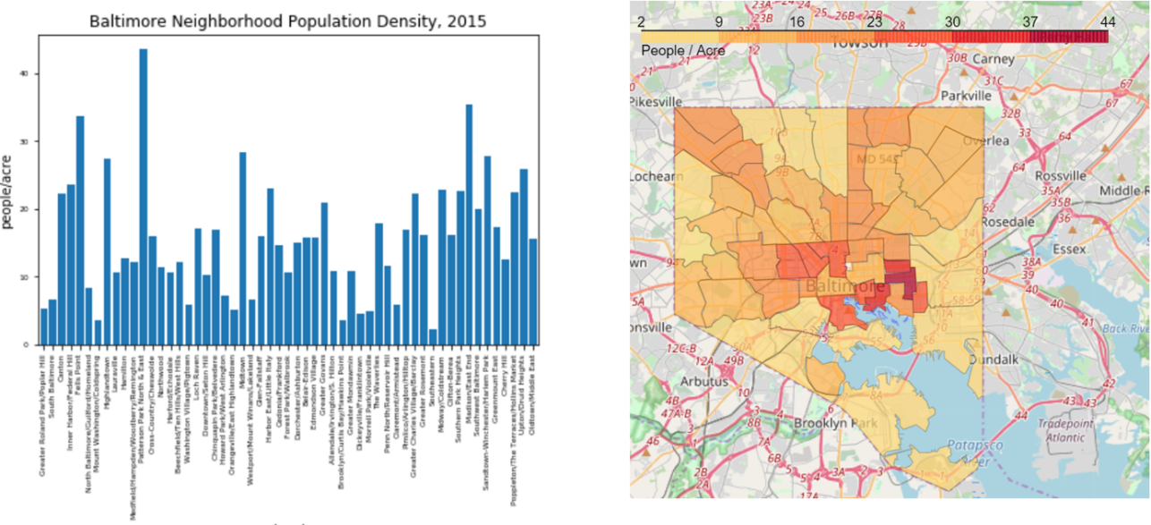

Figure: Neighborhood population density, 2015

## 3.3: Analysis:

Most per neighborhood

Summary tables

KNN clustering

# 4. Results

Neighborhood summaries

Clustering Map

Cluster summaries

# 5. Discussion

Recommendations:

Limitations of analysis:

Suggested improvements:

More current data

More relevant data:

Years of education

Professions

More accurate data:

Not using Foursquares

# 6. Conclusion:

1. <https://en.wikipedia.org/wiki/Baltimore>